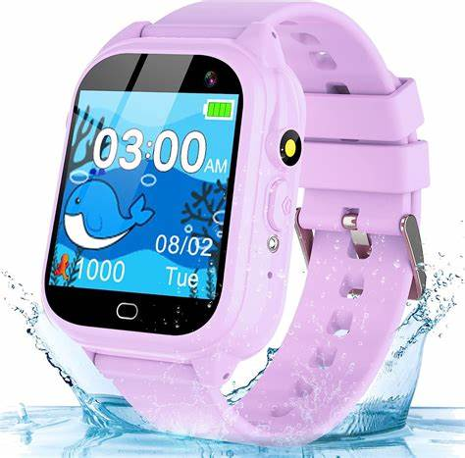**Description**: Phyulls offers a range of smartwatches designed specifically for children aged 3 to 12, combining entertainment, education, and practical features. These watches come equipped with a variety of functionalities, including interactive puzzle games, cameras for photos and videos, music players, and educational tools like calculators and habit trackers. The user-friendly HD touchscreens make navigation simple for young users, while the durable, comfortable materials ensure suitability for active children. With long-lasting rechargeable batteries, Phyulls smartwatches provide continuous engagement, making them an excellent gift choice for birthdays and special occasions.